

Computational Statistics (STA 161-1)
CIA-3
Topic: Work on a data analysis project to demonstrate your ability to handle real-world data
Domain: Government Sector/Employment

Submitted By: Submitted To:
Alister Luke Lewis Prof. MaryKripa
2541403 Department Of
1BScDS Statistics And
Data Science
Introduction:
The role of employment cannot be overemphasized in an economy and the overall development of a country. Employment is the measure of whether an economy can efficiently engage its available workforce to earn income, fight poverty, and maintain growth. The project centers on the study of employment patterns based on statistical procedures like correlation and regression analysis. The project gives a numeric and graphical insight into the way that employment changes over time, how it is affected by population growth and labour force activity, and whether or not particular trends can be employed as a means of projecting forward.
Employment is not merely an economic indicator, but an important measure of human development, social stability, and quality of life. A nation with high rates of employment tends to have greater productivity, more robust purchasing power, and improved living standards, whereas high unemployment can contribute towards economic stagnation and social issues. As a result, understanding patterns of employment is highly important for decision-makers, educators, and policy planners.
The value of this project can be considered in three ways:
It emphasizes the way levels of employment vary in response to population growth and labour force participation. It sheds light on structural changes in the workforce, including shifts from agricultural to non-agricultural sectors. It illustrates the contribution made by statistical methods in describing and forecasting trends in employment.
In context, analysis of employment is of greatest importance in framing labour policies, skill development schemes, and economic reforms. Governments and institutions like the International Labour Organization (ILO) and the World Bank follow similar methodologies to measure employment and unemployment across the world and countries. This project, though done at an academic level, mirrors actual practices and demonstrates how statistical analysis can be used to solve one of the most significant socio-economic problems which is employment
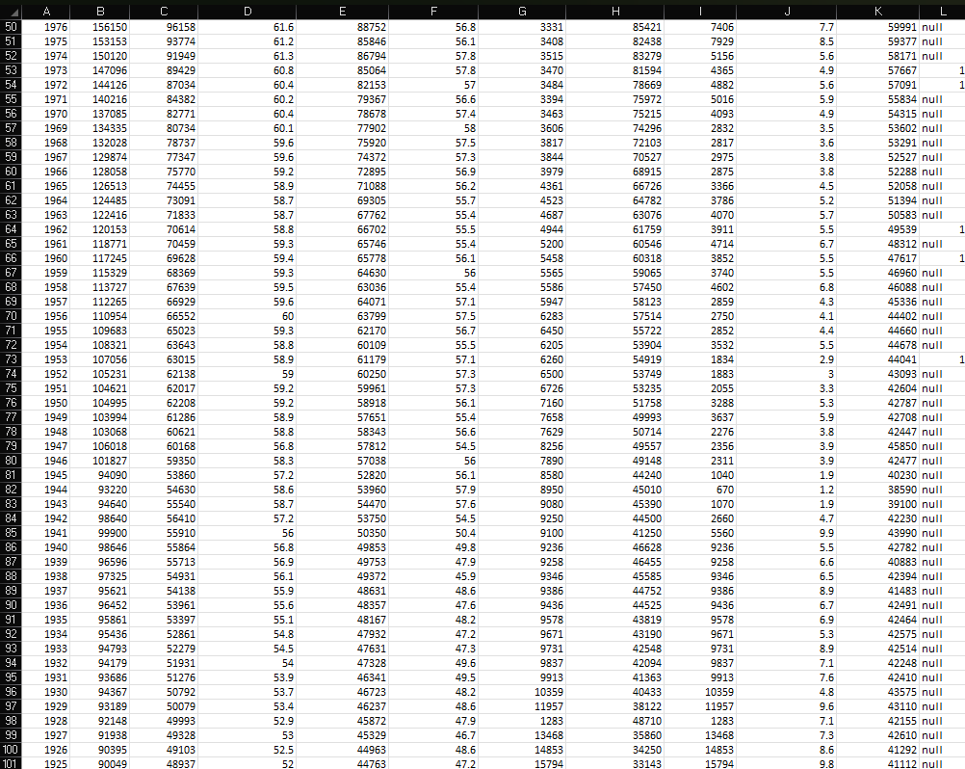
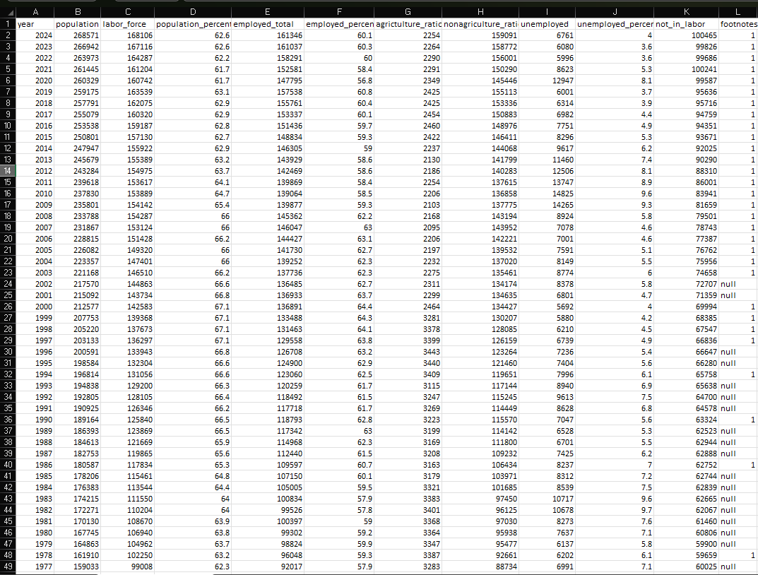
Raw Data:
Data Description:
The dataset used in this assignment is the ‘US Employment and Unemployment rates since 1925’, with 101 rows and 12 columns, with each row representing a yearly observation.
Variables in the dataset:
- year – The time indicator (year of observation).
- population – The total population during that year.
- labor_force – The number of people who are either employed or actively seeking employment.
- population_percent – The proportion of the population represented by the labour force.
- employed_total – The total number of people employed
- employed_percent – The proportion of the labour force that is employed.
- agrictulture_ratio – Number of employed individuals working in the agricultural sector.
- nonagriculture_ratio – Number of employed individuals working in the non-agricultural sector.
- unemployed – The number of people in the labour force who are unemployed.
- unemployed_percent – The proportion of unemployed individuals in the labour force.
- not_in_labor – The number of people not participating in the labour force.
- footnotes – Additional notes, if any, linked to the data.
Data Source:
This data was downloaded from US Government Data Source, ‘Data.gov’
Data Type and Structure:
- Quantitative variables: population, labour force, employed_total, unemployed, not_in_labor.
- Percentage/ratio variables: population_percent, employed_percent, agrictulture_ratio, nonagriculture_ratio, unemployed_percent.
- Categorical/text variable: footnotes.
- Time variable: year
Data Cleaning and Preprocessing:
- Checking for missing values:
- Go to home -> Find and select -> Go to special
- In the dialog box, choose blanks -> Click Ok
- Excel will highlight all empty cells
- The dataset was carefully checked and no missing values were found in it
- Checking for duplicate values:
- Select the ‘Year’ column to check if there are repetition of same years
- Go to data -> Remove Duplicates -> Click Ok
- Excel will remove duplicate entries and show how many were deleted
- No duplicate values were found, ensuring there was no repetition of years
- Removing Irrelevant Entries:
- The “footnotes” column was separated as metadata and deleted, since it does not directly contribute to statistical analysis.
- Select the whole column -> Go to home -> Delete -> Delete cells
- Formatting the dataset:
- Selected the whole dataset and formatted it into table, making it look clean and neat
- The first word of all the headings have been changed to capital and all the headings were made bold to recognise the type of data we are dealing with.

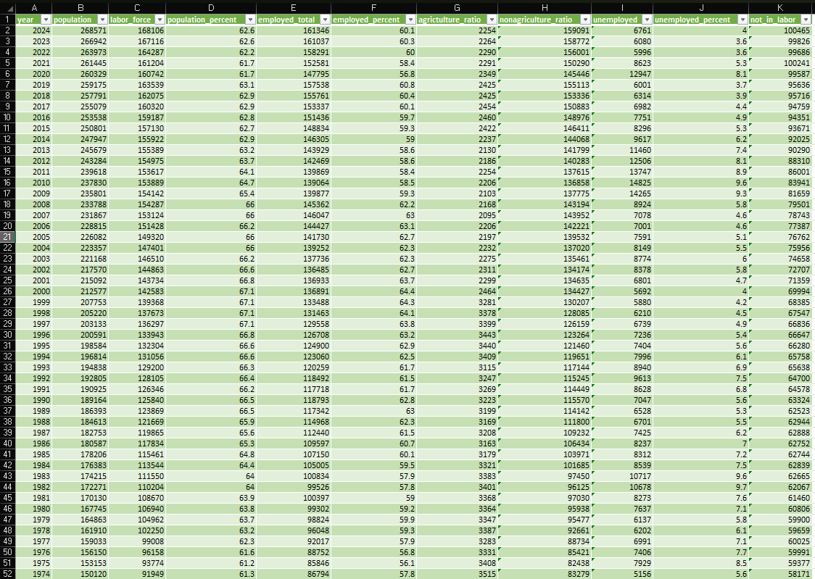
Data After Cleaning And Preprocessing:
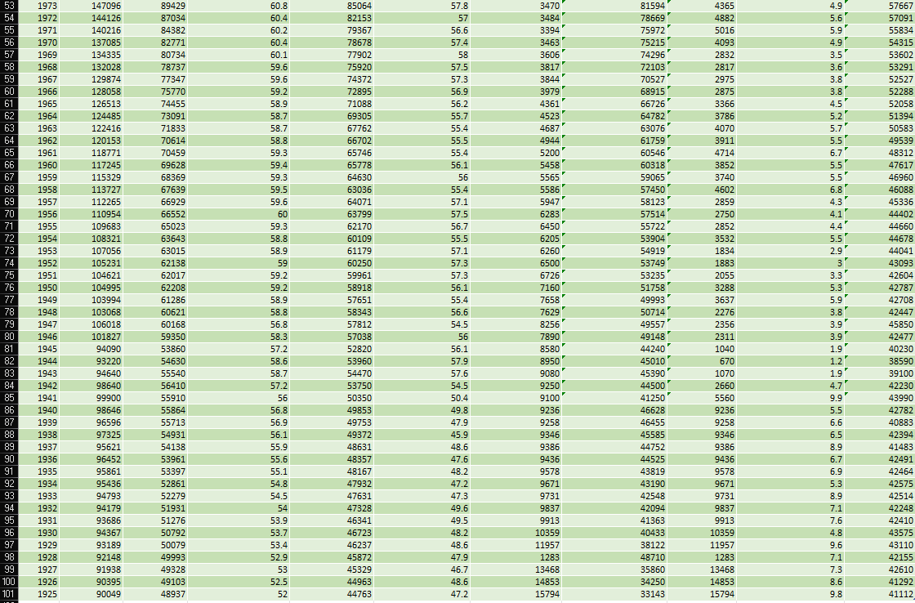

Objectives:
The overall aim of this project is to study employment trends and explore determinants of the trends through statistical analysis. More particularly, the project aims to:
- Appreciate employment patterns over time by investigating the association among employment, population, and labour force participation.
- Quantify the association between employment and other associated socio-economic factors (population, labour force, unemployment, and sectoral proportions) through correlation coefficients.
- Construct a regression model to illustrate and forecast levels of employment in light of major independent variables like population and labour force.
- Make a comparison of sectoral employment patterns, mainly the transition from agricultural to non-agricultural, and evaluate its effects on levels of employment overall.
- Draw conclusions and make suggestions that would consider how employment policy or manpower strategies might be informed by statistical data.

Methodology:
1.Calculating Descriptive statistics for some important columns:
    - For Column “Population”:
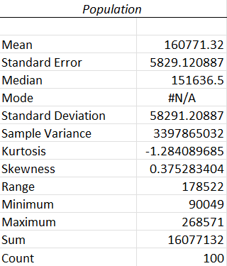

- Min = 90,049 (1925), Max = 268,571 (2024) → Population has nearly tripled over the century.
- Range = 178,522 → Shows a massive increase over time.
- Mean = 160,771 → Typical population size.
- Std Dev = 58,291 → Large variation due to steady growth.
- Indicates strong population expansion, driving labour force growth.
- Skewness = +0.37 → Slight right-skew, meaning recent years have much higher populations.
- Kurtosis = -1.28 → Flatter distribution, no extreme outliers.
- Shows steady growth, with higher values more common in later years.

  - For Column “Labour Force”
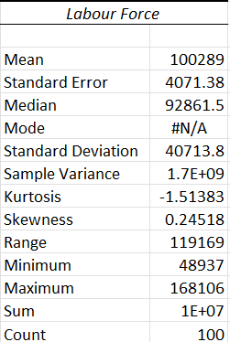

- Min = 48,937 (1925), Max = 168,106 (2024) → Labour force has grown more than threefold.
- Range: Shows strong expansion of workforce availability.
- Mean (100,289): Represents the average labour force size.
- Std Dev (40,714): Significant variation, reflecting demographic growth and economic changes.
- Skewness = +0.24 → Slight right-skew, labour force also increases over time.
- Kurtosis = -1.51 → Flatter spread, no sharp peaks.
- Growth in labour force is consistent with population expansion.

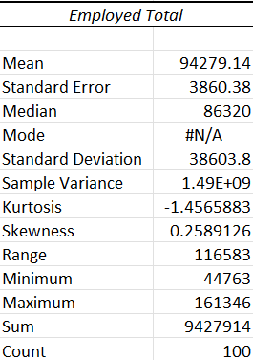
- For Column “Employed Total”

- Min = 44,763 (in 1925), Max = 161,346 (in 2024) → Employment numbers grew steadily.
- Mean = 94,279 → Average employment over the years.
- Std Dev = 38,604 → Wide spread reflects major job creation as the economy developed.
- This indicates long-term expansion in employment opportunities.
- Skewness = +0.26 → Right-skew, more people employed in recent years.
- Kurtosis = -1.46 → Flat distribution, values spread out.
- Reflects employment expansion over decades.

- For Column “Unemployed"
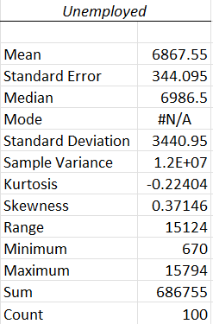

- Min = 670 (in 1929), Max = 15,794 (in 2020) → Shows unemployment crises during certain years.
- Mean = 6,868 → Typical unemployment level.
- Std Dev = 3,441 → Indicates noticeable fluctuation.
This highlights economic cycles, with peaks in bad years (like 2020).
- Skewness = +0.37 → Right-skew, meaning unemployment was low for many years but spiked in certain years (e.g., 2020).
- Kurtosis = -0.22 → Fairly normal, slightly flat
- Captures rare unemployment surges during crises.

Steps to get Descriptive statistics for each column:
Step 1: Enable the Data Analysis ToolPak
- Go to the File tab → Options.
- In the Excel Options window, click Add-ins.
- At the bottom, in the Manage box, select Excel Add-ins → click Go.
- Check the box for Analysis ToolPak → click OK.
Now, you’ll see Data Analysis under the Data tab (in the “Analysis” group).

Step 2: Open the Descriptive Statistics Tool
- Go to the Data tab.
- Click Data Analysis (on the right).
- Select Descriptive Statistics → click OK.

Step 3: Select Your Data
- In the dialog box, under Input Range, select the column of data you want to analyze (e.g., Employment).
  - If you want to analyze multiple columns, select the full range.
- Choose Columns (if your data is column-wise) or Rows (if row-wise).
- Check the box Labels in First Row if your data has column names.

Step 4: Output Options
- Choose where to display results:
  - Output Range (on the same sheet)
  - New Worksheet Ply (in a new sheet)
  - New Workbook
- Check the box Summary statistics.
Step 5: Get the Results
Click OK → Excel will generate a table

2.Calculating Quartiles and Percentiles:
- Quartiles can be obtained by using the formula:
=QUARTILE.EXC(array, quart)
- Percentiles can be calculated using the formula:
=PERCENTILE.EXC(array, k)

1,2,3 Quartiles for each column:

10,20,30 Percentiles for each column:

3.Data Interpretation:
- Select the rows and columns u want graphs of.
- Go to Insert -> Charts -> Select the charts of your choice.
- Right click on the chart, you will be able to customise accordingly to make it look neat and clean.
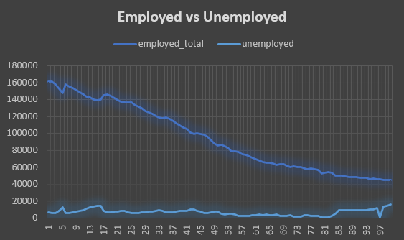
1.Employed vs Unemployed:
- Employed is significantly greater than unemployed for all years.
- Total employment gradually decreases over time in the dataset.
- Unemployment experiences minor fluctuations but experiences sudden peaks
- This points out that whereas the majority of the population is employed, unemployment pressures escalate in times of economic depression
2.Agriculture vs Non Agriculture:
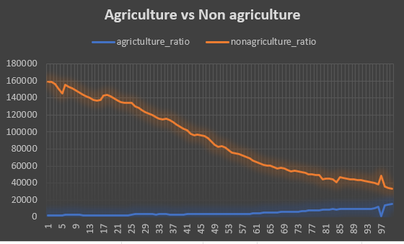

- Non-agriculture employment prevails in the dataset.
- Agriculture employment is extremely low in comparison to non-agriculture.
- As time passes, there is a growing gap, which indicates a shift in the structure of the economy:
- Initial years were more agriculture-dependent.
- Subsequent years indicate industrialization and service growth.
- This illustrates how there was a shift from a traditional to a modern economy.

3.Population vs Labour force:
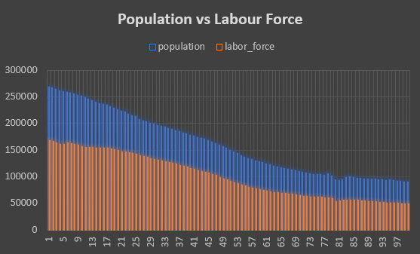

- Population is always greater than the labour force (as one would expect, because not everyone is employed).
- Population and labour force both exhibit the same decreasing trend in the data.
- The difference between population and the labour force indicates individuals not in the labour force (students, retirees, homemakers, etc.).
- This indicates that although population does grow overall in the real world, within the dataset there is fluctuation that could indicate sampled or adjusted values over time.

Conclusions and Recommendations:
Conclusions:
- The long-term trend in the analysis is one of steady growth in population and labour force, with demographic expansion as a major factor behind employment trends.
- Employment has increased but not at the same rate as the labour force, resulting in fluctuations in employment rates.
- Unemployment rates, though generally low, have experienced periodic spurts, particularly during times of economic recession (e.g., 1982, 2020).
- A remarkable structural change is witnessed:
- Agriculture employment has decreased precipitously,
- Non-agriculture employment has increased steadily, a sign of modernization and sectoral change.
- The percentage of people not in the labour force has also increased in some phases, associated with greater participation in higher education, ageing population, and social change.

Recommendations:
- Job Creation Policy Focus: Governments must continue to generate employment in high-growth non-agriculture industries (IT, services, manufacturing).
- Modernization of Agriculture: As agriculture employment is declining, modernization and mechanization can assist in maintaining productivity while shifting surplus labour to other areas.
- Development of Skills: Spending in education and vocational training is imperative in order to bring workforce skills into line with industry requirements.
- Unemployment Prevention: Early warning systems and safety nets need to be enhanced to cope with economic crises (e.g., pandemics, recessions).
- Labor Force Participation: Enhance greater participation, particularly by women and youth, through supportive policy measures (child care, flexible jobs, entrepreneurship schemes).
- Balanced Growth: Regional balance needs to be ensured so that rural as well as urban areas reap the gains from employment growth.

References:
- Employment and Unemployment Statistics Dataset (1925–2024), from US Government Data Source, ‘Data.gov’
- Microsoft Excel (Office 365) with Data Analysis ToolPak.
- Microsoft Support. (2024). Use the Analysis ToolPak to perform complex data analysis in Excel. Available at: https://support.microsoft.com
- ChatGPT, OpenAI. (2025). Personal consultation on data analysis techniques and report formatting.

